Choosing the Best Heater

Assessment Type  Real-life application of mathematics | Recommended Grade Level  Grade 7 (MYP2) | MYP Criterion Level  MYP 1

MYP Assessment Criteria  Criterion C: Communicating  Criterion D: Applying mathematics in real-life contexts | MYP Command Terms Used  apply, select, state, show, identify, state, describe, explain, use

MYP Global Context
Orientation in space and time
MYP Key Concepts  Aesthetics, Relationships | MYP Related Concepts  Models, Space

MYP Branch of Mathematics
Spatial reasoning
MYP Topics and Skills  - Area of plane figures, including triangles, rectangles, trapezoids, and compound shapes  - Volume of cubes, cuboids, cylinders, and prisms | Prior Knowledge Needed  - Metric conversions  - Calculating area of basic 2D shapes  - Calculating volume of basic 3D shapes
Assessment Description

In this assessment, students are given several diagrams of a bedroom with labeled dimensions of the room and the furniture. Students are then tasked with choosing the best possible heater for the room based on several conditions, such as cost, fit, and space that the heater can heat. The different pieces of furniture in the room are of different shapes, so students need to know how to calculate the areas and volume for each of them.

Materials Needed

Scrap paper, pencil, calculator (highly recommended), ruler (optional)

Task-specific instructions / Recommendations
It is recommended to print this assessment in color for students to have a clear visual to see. This is an assessment that requires a lot of calculation, so it is recommended that students can use a calculator and are given enough time to complete the task.

Assessment Criterion C: Communicating

 | Achievement Level Descriptor  (MYP1) | Task Specific Descriptor
0 | The student does not reach a standard described by any of the descriptors below.
1-2 | The student is able to:  - use limited mathematical language  - use limited forms of mathematical representation to present information  - communicate through lines of reasoning that are difficult to understand  - (not demonstrated at this level). | The student is able to:  - use a minimal amount of mathematical vocabulary  - use one of the following effectively, but with errors: tables, diagrams, calculations, and written explanations  - present arguments that are difficult to understand  - (not demonstrated at this level).
3-4 | The student is able to:  - use some appropriate mathematical language  - use appropriate forms of mathematical representation to present information adequately  - communicate through lines of reasoning that are able to be understood, although these are not always coherent  - adequately organize information using a logical structure. | The student is able to:  - use some appropriate mathematical vocabulary  - use two of the following effectively, but with minor errors: tables, diagrams, calculations, and written explanations  - present arguments that can generally be understood, however are not always coherent  - organize working out somewhat adequately using some form of logical structure
5-6 | The student is able to:  - usually use appropriate mathematical language  - usually use appropriate forms of mathematical representation to present information correctly  - communicate through lines of reasoning that are usually coherent  - present work that is usually organized using a logical structure. | The student is able to:  - usually use appropriate mathematical vocabulary  - use at least three of the following effectively: tables, diagrams, calculations, and written explanations  - present arguments that are usually coherent  - usually organize working out using a logical structure
7-8 | The student is able to:  - consistently use appropriate mathematical language  - consistently use appropriate forms of mathematical representation to present information correctly  - communicate clearly through coherent lines of reasoning  - present work that is consistently organized using a logical structure. | The student is able to:  - consistently use appropriate mathematical vocabulary  - use at least four of the following effectively throughout the investigation: tables, diagrams, calculations, and written explanations  - present clear arguments that are consistently coherent  - consistently organize working out using a logical structure

Assessment Criterion D: Applying mathematics in real-life contexts

 | Achievement Level Descriptor  (MYP1) | Task Specific Descriptor
0 | The student does not reach a standard described by any of the descriptors below.
1-2 | The student is able to:  - identify some of the elements of the authentic real-life situation  - apply mathematical strategies to find a solution to the authentic real-life situation, with limited success  - (not demonstrated at this level)  - (not demonstrated at this level)  - (not demonstrated at this level). | The student is able to:  - identify some of the main elements needed to solve the problem  - find a volume of the empty space in the room that is within 5 cubic meters of the correct answer, but doesn’t choose the best heater based on that finding  - (not demonstrated at this level)  - (not demonstrated at this level)  - (not demonstrated at this level).
3-4 | The student is able to:  - identify the relevant elements of the authentic real-life situation  - apply mathematical strategies to reach a solution to the authentic real-life situation  - (not demonstrated at this level)  - (not demonstrated at this level)  - state, but not always correctly, whether the solution makes sense in the context of the authentic real-life situation. | The student is able to:  - identify all of the main elements needed to solve the problem  - find a volume of the empty space in the room that is within 2 cubic meters of the correct answer, and chooses the best heater based on that finding  - (not demonstrated at this level)  - (not demonstrated at this level)  - state briefly, but not always correctly, why the heater chosen is the best.
5-6 | The student is able to:  - identify the relevant elements of the authentic real-life situation  - select adequate mathematical strategies to model the authentic real-life situation  - apply the selected mathematical strategies to reach a valid solution to the authentic real-life situation  - describe the degree of accuracy of the solution  - state correctly whether the solution makes sense in the context of the authentic real-life situation. | The student is able to:  - identify all of the main elements needed to solve the problem  - select the correct area and volume formulas for at least 5 objects/furniture in the room  - find the volume of the empty space in the room within 1 cubic meters of the correct answer, and chooses the best heater based on that finding  - describe why he/she believes the volume of the empty space found is accurate  - state correctly but briefly, why the heater chosen is the best
7-8 | The student is able to:  - identify the relevant elements of the authentic real-life situation  - select adequate mathematical strategies to model the authentic real-life situation  - apply the selected mathematical strategies to reach a correct solution to the authentic real-life situation  - explain the degree of accuracy of the solution  - describe correctly whether the solution makes sense in the context of the authentic real-life situation. | The student is able to:  - identify all of the main elements needed to solve the problem  - select the correct area and volume formulas for all objects/furniture in the room  - find the correct volume of empty space in the room and choose the best heater  - explain why he/she believes the volume of the empty space found is accurate  - describe correctly why the heater chosen is the best

Introduction

Johnny’s parents recently re-modeled the attic of their house so that Johnny could make it his new bedroom. The attic includes a slanted ceiling that can be seen in the model diagrams of the room that you will see as you start this task.

Johnny needs to buy a heater for his room. However, he realizes that he has limited space in his new room for a heater and has only saved $400 in his piggy bank to spend on one. Johnny would like to spend as little money as possible while making sure that the heater can heat the empty space in his room and be able to place it somewhere unintrusive.

Johnny searches an online store and finds several heaters that he likes and records the essential information into a list as seen in the next page. The information includes the following:
- The size of the heater (based on dimensions given)
- Notes on the direction the heater should face
- The amount of empty volume it can heat
- The cost of the heater
To help figure out which heater would be the best to buy, Johnny used a special software called Sketchup to construct a model diagram of the room. He also took measurements of all the different furniture and which can all be found between three different screenshots of the model room that Johnny has printed out. These screenshots can be found on the pages after the list of heaters.

There are certain things Johnny has decided already regarding where he can put the heater:
- It must have a side that touches a wall.
- It cannot be in front of, or on any furniture, doors, or windows.
- Furniture cannot be moved to make space for the heater. Johnny likes the Feng Shui of his room!
Tasks

Johnny has asked you to write a report that tells him what is the best option for a heater, where in the room it should be placed, and why. To do this, you will need to apply and select problem solving techniques to analyze the list of heaters and diagrams.

Final Report: On the last page there is a space for you to write your final report. In this report, you should make sure you do the following:

- State what objects in the room take up space.
[D: 1-8, i]
- Show your working out to find the volume of the empty space is in the room.
[D: 1-8, ii]
- Identify and state what you believe to be the best heater for Johnny.
[D: 1-8, iii]
- Describe why you believe that this is the best possible heater for Johnny.
[D: 1-8, v]
- Explain with reasons on how accurate you believe your findings for the volume of empty space in the room is.
[D: 1-8, iv]

Heaters found for sale online:
______________________________________________________________________________
Heater 1:
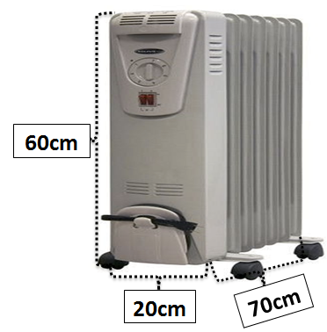
Notes: Can face any direction: Must stay on its wheels.

Volume that can be heated: 45,000,000cm³

Price: $140
______________________________________________________________________________
Heater 2:
Notes: Back side must be mounted at least 1 meter above the floor. Back must be mounted to the wall.

Volume that can be heated: 49,000,000cm³

Price: $165

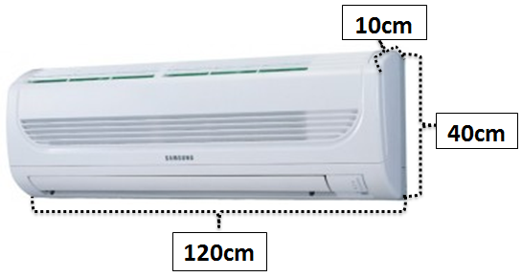
______________________________________________________________________________
Heater 3:
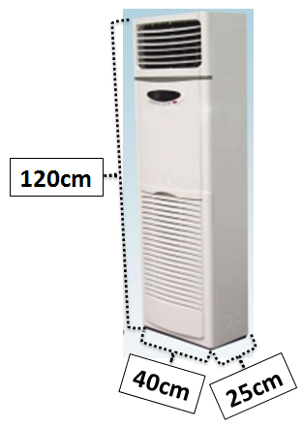______________________________________________________________________________
Heater 4:
Notes: Back side must be against the wall. Bottom must touch the floor.

Volume that can be heated: 52,000,000cm³

Price: $215

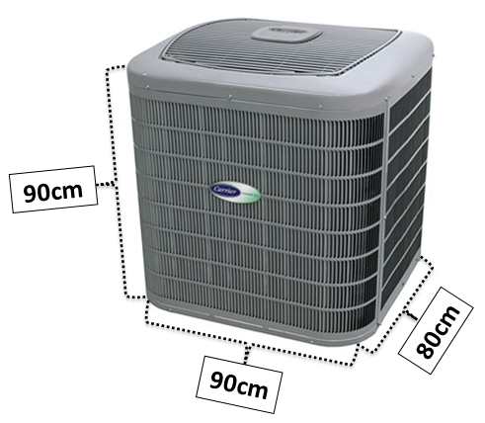
Notes: Bottom must touch the floor. One of the adjacent sides must touch the wall.

Volume that can be heated: 55,000,000cm³

Price: $415


(Third diagram found on next page)
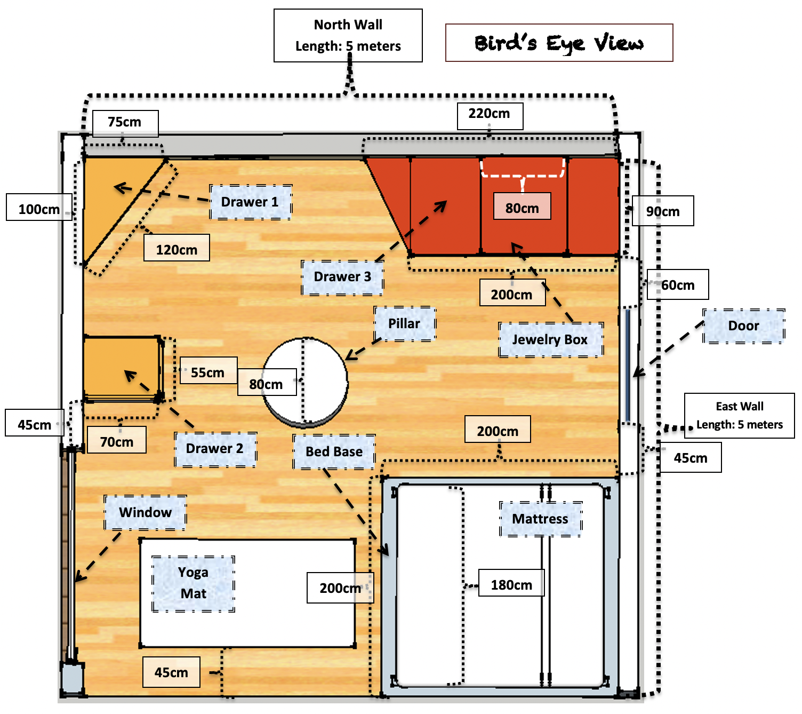
**Note that the mattress is square shaped.**
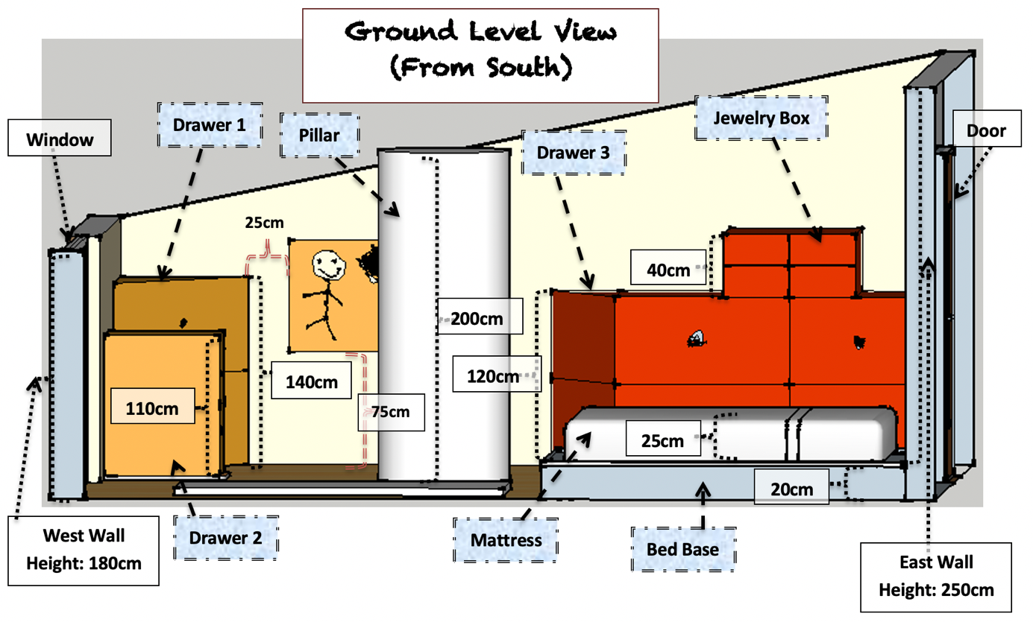

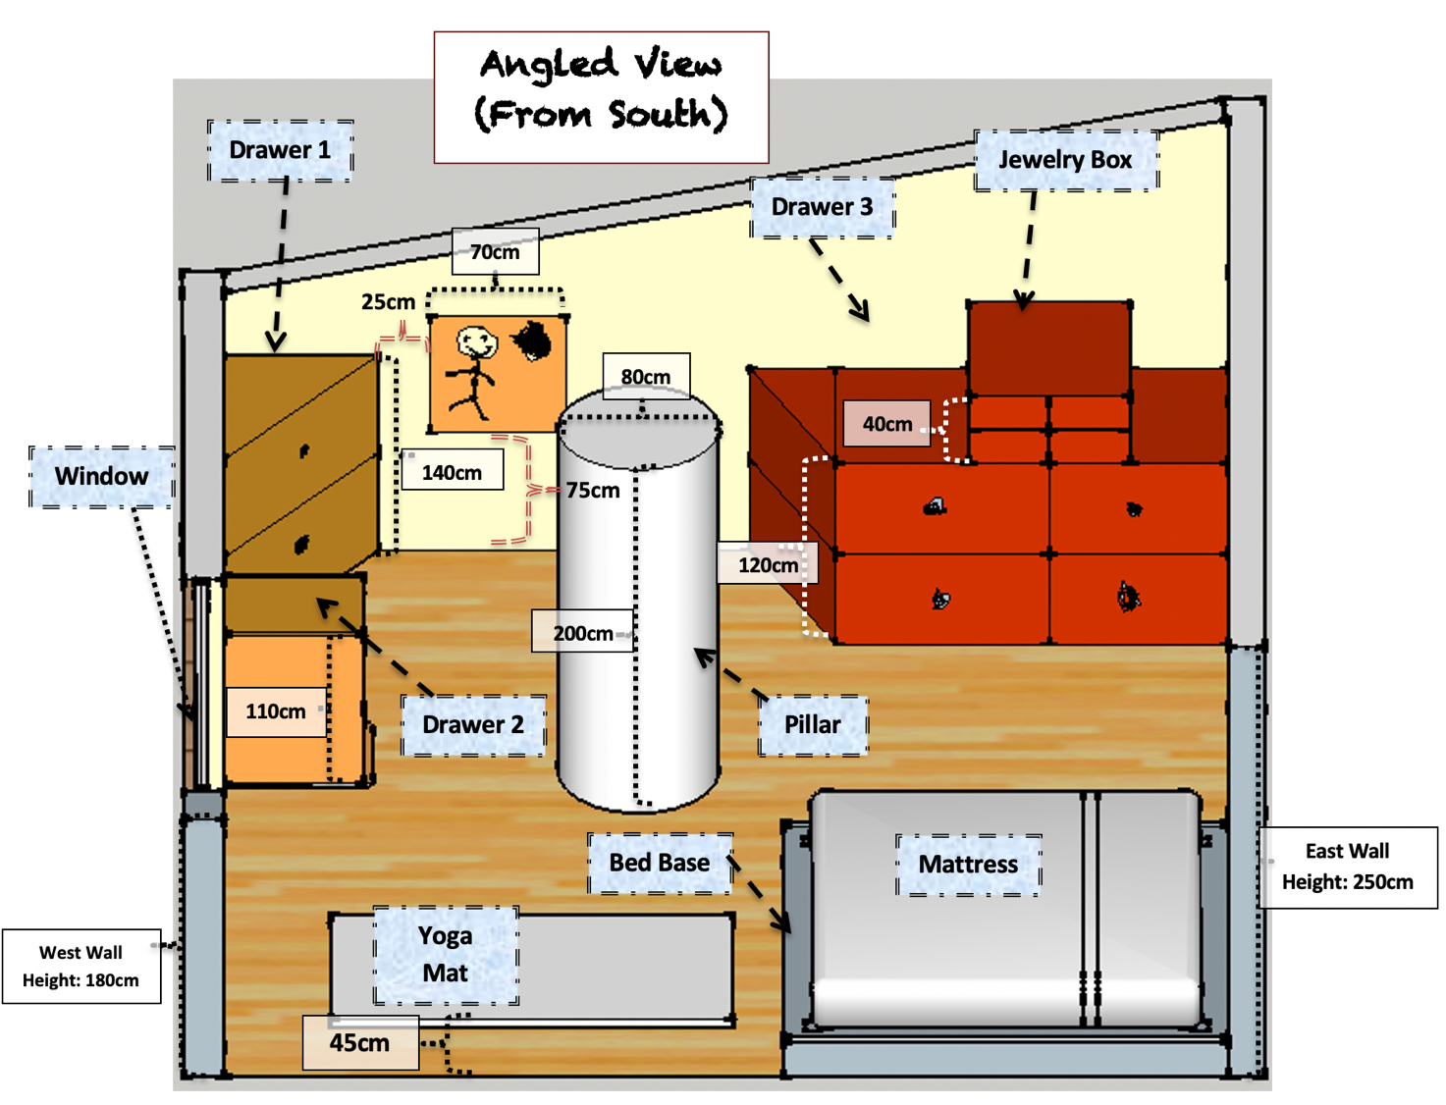
**Note that the mattress and the painting on the wall are both square shaped.**

Final Report: Remember that in your report you should do the following:
- State what objects in the room take up space.
[D: 1-8, i]
- Show your working out to find the volume of the empty space is in the room.
[D: 1-8, ii]
- Identify and state what you believe to be the best heater for Johnny.
[D: 1-8, iii]
- Describe why you believe that this is the best possible heater for Johnny.
[D: 1-8, v]
- Explain with reasons on how accurate you believe your findings for the volume of empty space in the room is.
[D: 1-8, iv]

Communication: you will also need to show thorough working out so that your audience can understand your thought process. As you do so make sure to do the following:
- Use appropriate mathematical vocabulary that has been discussed throughout the unit.
[C: 1-8, i]
- Show your thinking and answers in such a way that is clear, coherent, and organized, that includes multiple forms of representation such as tables, diagrams, calculations, and supporting explanations, etc.
[C: 1-8, ii-iv]
** Before starting your final report, it is advised to do a draft on scrap paper first.**

